Use the A/D converter
Things to remember:
- The input voltage may not be greater than 5.0 volts.
- Since only integer math is provided, the reading will be in hundredths of a volt.
- Use a potentiometer to vary the voltage.

Application 1:
Read the voltage and print it out on the screen. Repeat every 5 seconds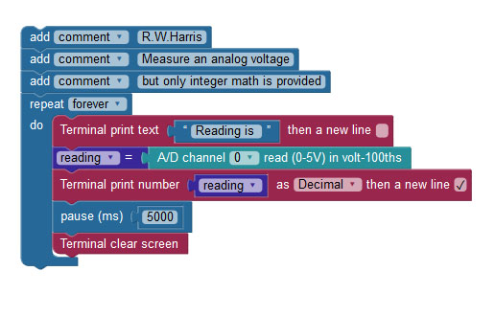
Application 2:
Add a red and a green LED (each with an appropriate resistor). If the reading is less than 4 volts then the green LED should flash intermittently.
If the voltage is 4 volts or greater the red LED should flash intermittently.

Applications 3:
Add a piezo speaker. The speaker should beep intermittently with its frequency proportional to the voltage.

